1. **Introduction**

**1.1 Scope of the Project**

An event management app for college events is a software application that enables colleges to effectively manage all aspects of their events. The app is designed to streamline the event management process and simplify the tasks involved in organizing and executing successful events.

**1.2 Existing System**

The existing system is not used effectively and it is not updated on daily basis and lacks user registration in the college website.

**1.3 Proposed System**

An event management app for college events is a web application helps users to register for events, also search for events via search bar in the web app, all the events and the users registered are stored in database , each user uses their mail id to register for the website and can register for any event of their choice.

1. **System Analysis**

The proposed project aims to develop an application that enables effective event status and management. The application will support the complete event management process from planning to execution and evaluation. The objective of this feasibility study is to assess the viability of the project and determine if it is feasible to proceed with its development

* 1. **Feasibility**

**2.1.1 Operational Feasibility**

The operational feasibility of the project will depend on the application's ability to meet the needs of its target audience. The application will support event managers. We need to conduct a comprehensive needs assessment to identify the key features and functionalities that the application must include to meet the needs of its users.

**2.1.2 Technical Feasibility**

To develop the application, we need to assess the technical feasibility of the project. Our development team has the required expertise and knowledge to develop the application within the proposed timeframe

**2.1.3 Economical Feasibility**

We need to assess the economic feasibility of the project by analysing the cost-benefit ratio. The project will require a considerable investment of time and resources to develop and deploy the application. We will need to conduct.

**2.2 Functional Requirements**

Functional requirement defines a function of a software system or its component. A function is described as a set of inputs, the behaviour, and outputs. Functional requirements may be calculations, technical details, data manipulation and processing and other specific functionality that define what a system is supposed to accomplish. Behavioural requirements describing all the cases where the system uses the functional requirements are captured in use cases.

NUMBER OF MODULES

The system after careful analysis has been identified to be presented with the following modules:

Event Status and Management Module

In EMS project we use React js, Node js and Mongodb database. It has two modules.

**User Module**

**Admin Module**

**User Module:**

1. Users can register for events

2. chat in chat channels,

3. see map to figure out where the event is happening,

4. change profile information,

5. view club information, also the event status.

**Admin Module:**

Admins create clubs, events, delete events, users, all CRUD operations are possible from the admin’s side.

**2.3 Non-Functional Requirements**

Reliability:

In this system reliability means the mail which is send by the source must reach the target user with any modification and accurate.

Security:

The web server and database server should be protected from hacking, virus etc

For which xss headers, data sanitisation, rate limiting are setup

Portability:

The application will be developed using Node js , React js and mongo db, software will work both on Windows and Linux os as it is a web application

Availability:

This software will be available always.

**2.4 Hardware requirements**

Processor : Intel P-IV based system

Processor Speed : 2.0. GHz

RAM : 128 MB

**2.5 Software requirements**

Browser : Chrome or Firefox or any browser

Database : Mongo db

Server : Node js

Frontend : React js

Scripting language : Java Script

IDE : VSCODE

Technology : MERN

1. **System Design**

**3.1 UML Diagrams**

3.1.1 Use case diagram

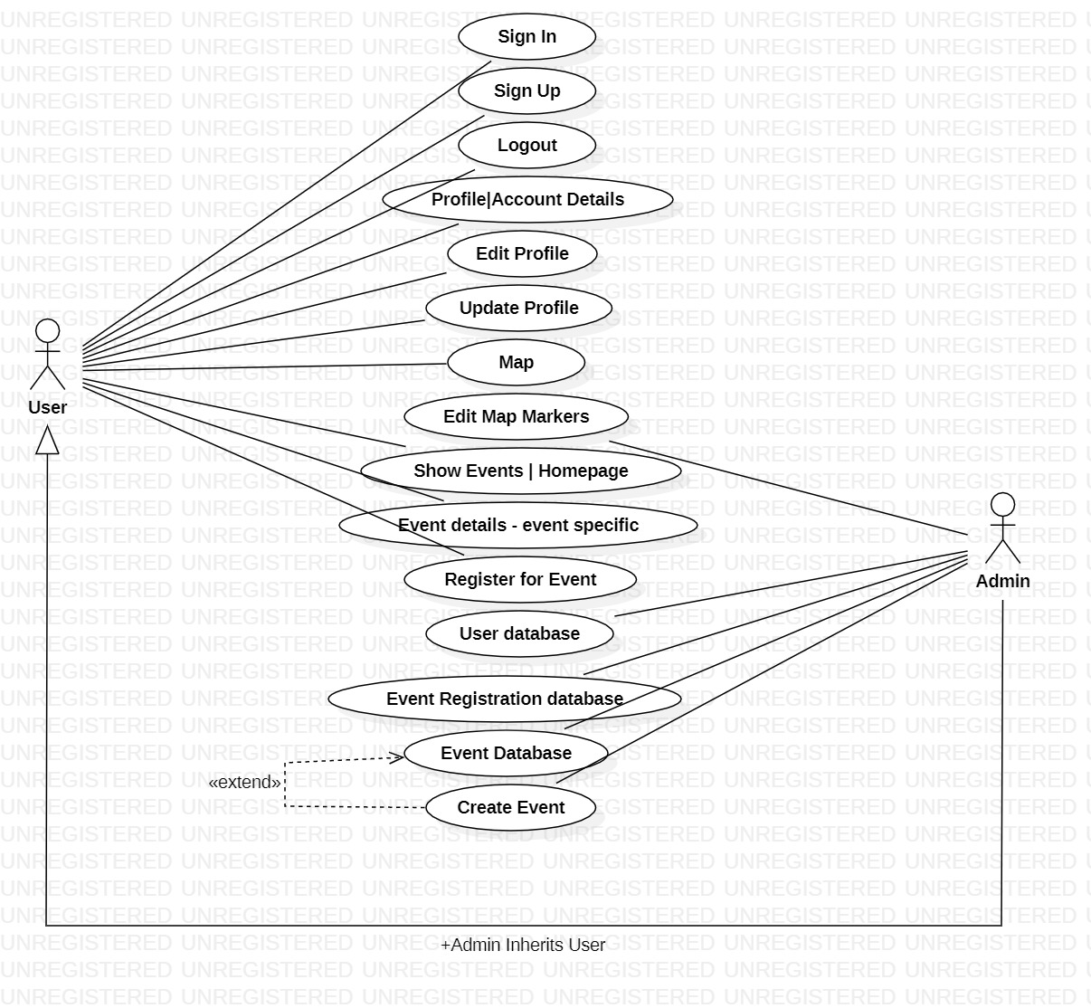

3.1.2 Database Design

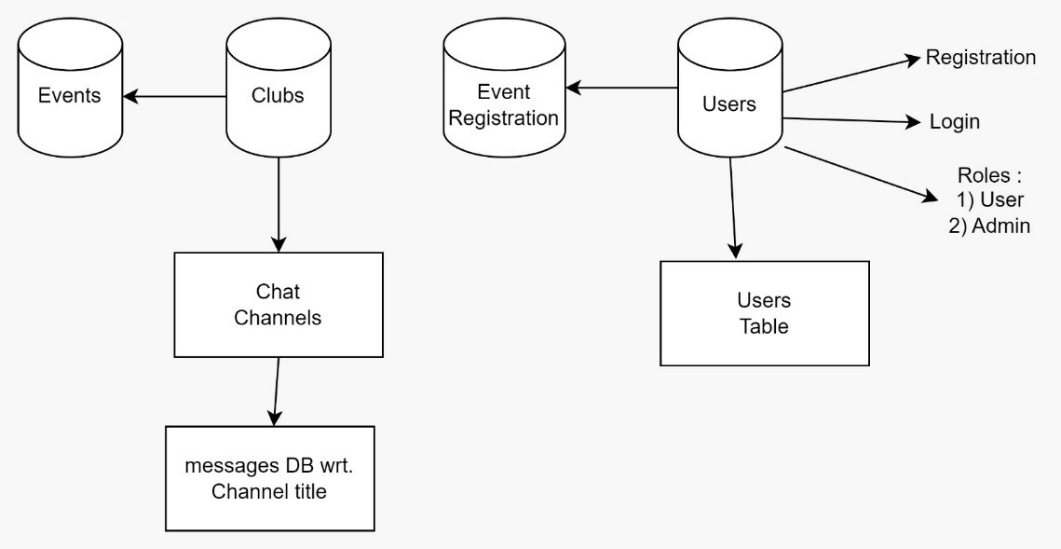

1. **Implementation**

**4.1 Technology used**

Node js - backend in javascript language uses V8 engine

React js – A frontend framework to create beautiful and customisable UI

Database : Mongo db (No SQL )

1. **Testing**

**5.1 Manual Testing**

Each of the functionalities is tested manually without any software, manual entering of data and validating it, checking each website properly.

1. **Output Screen of Project**

**6.1 Output screen of project**

The Desktop Mode

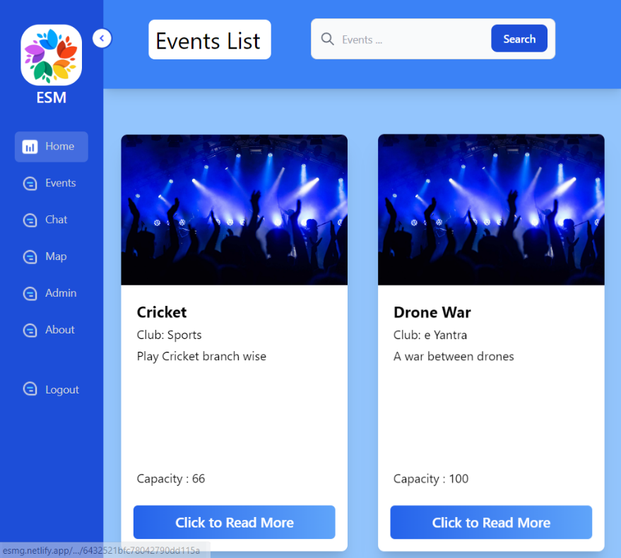

Installable through chrome desktop

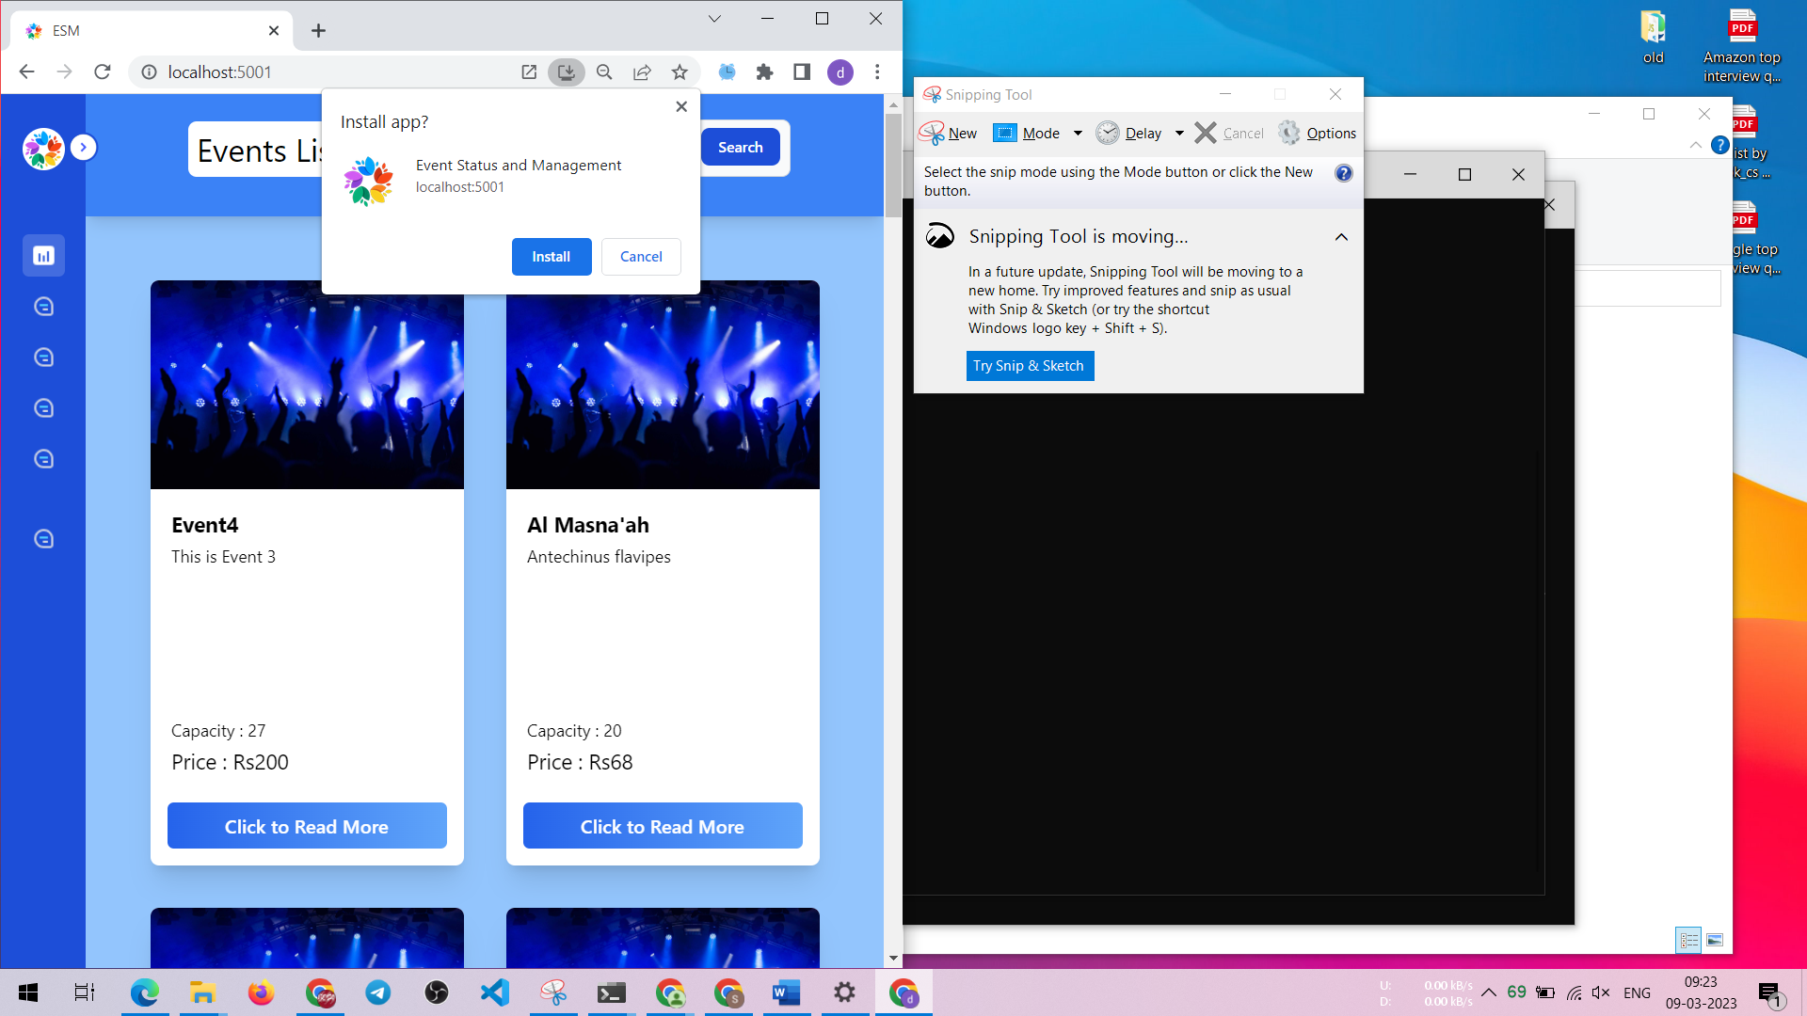

Sign in Page

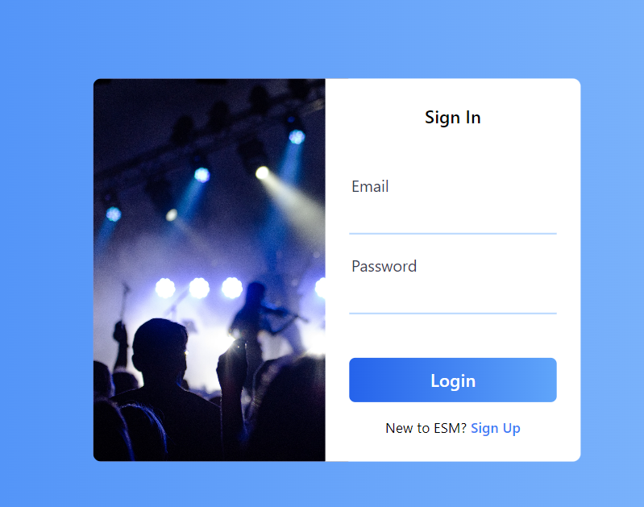

Installable through chrome mobile

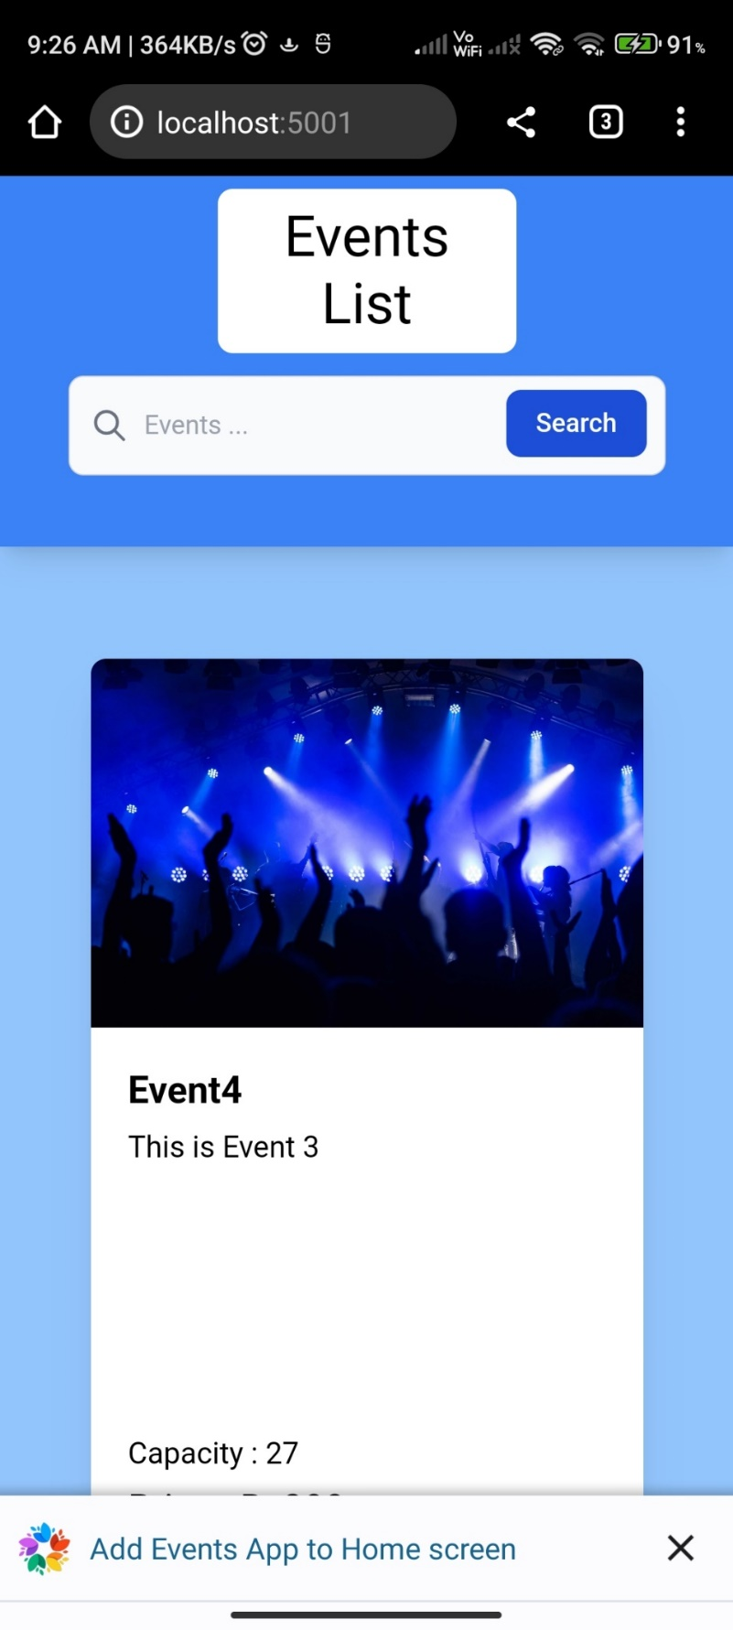

Mobile View

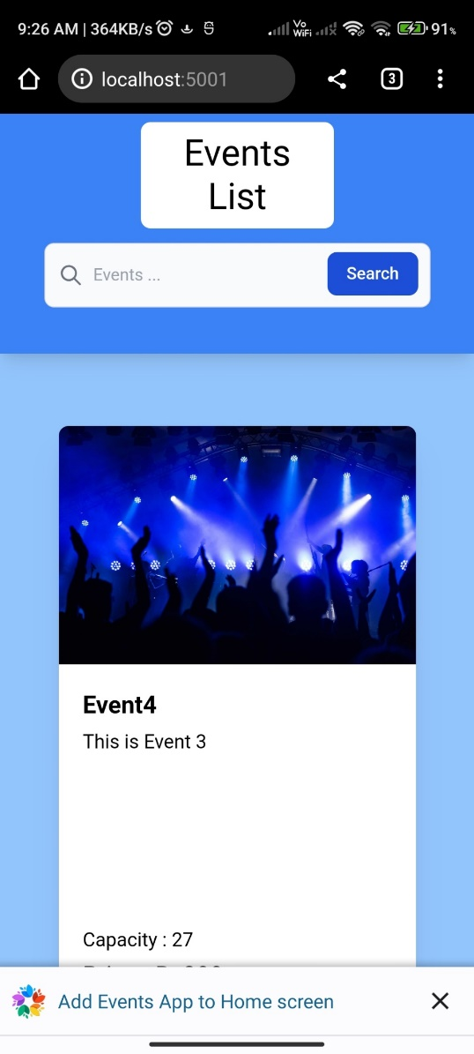

Event Page

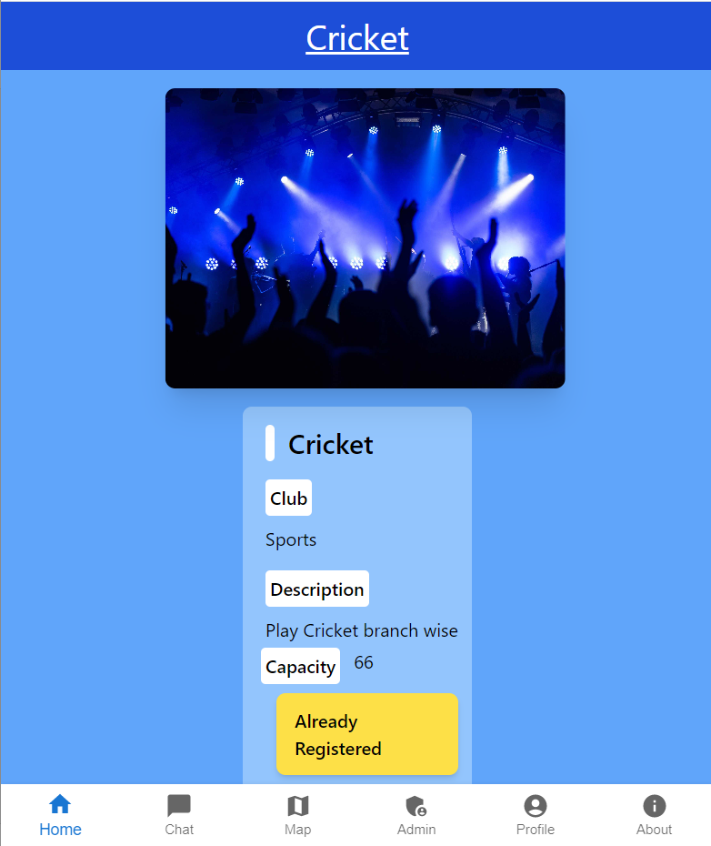

Register Page for event

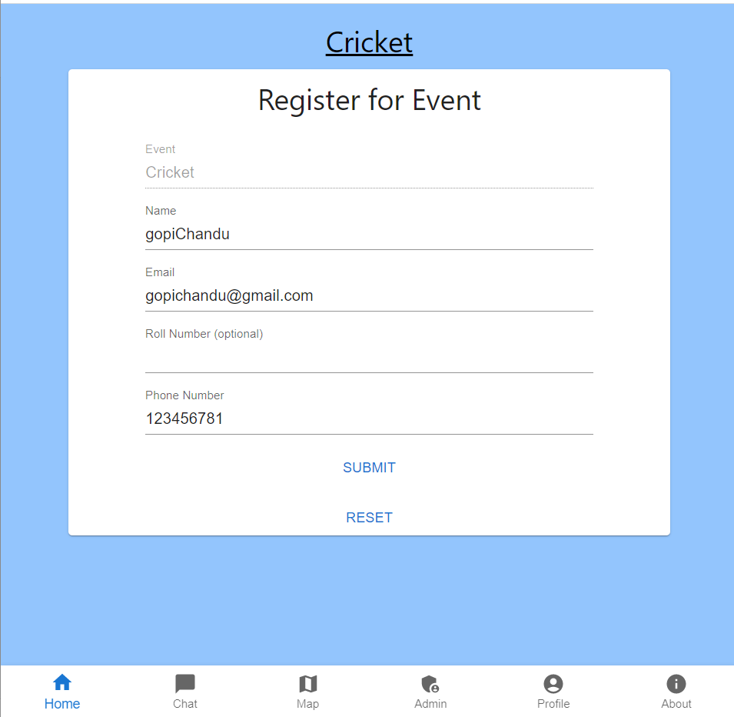

Chat

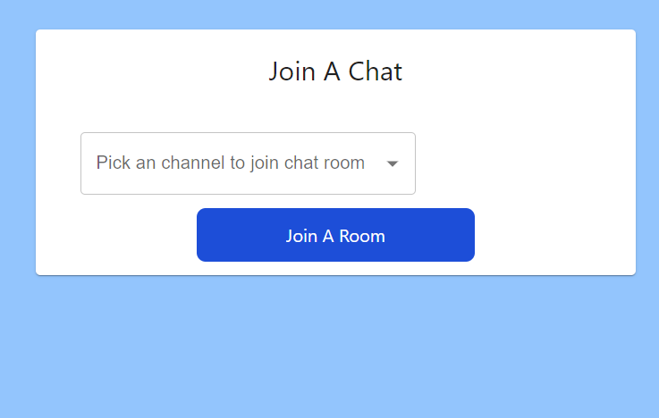

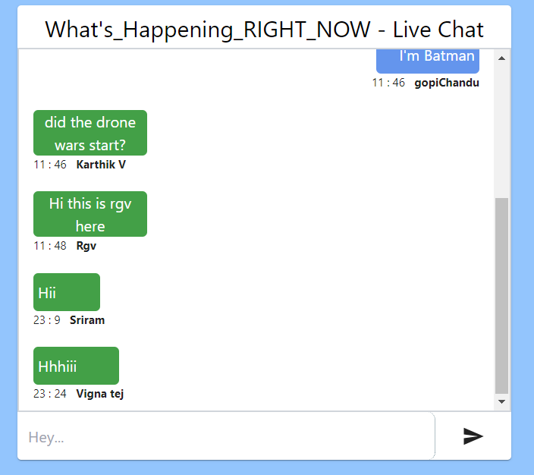

Admin view - clubs

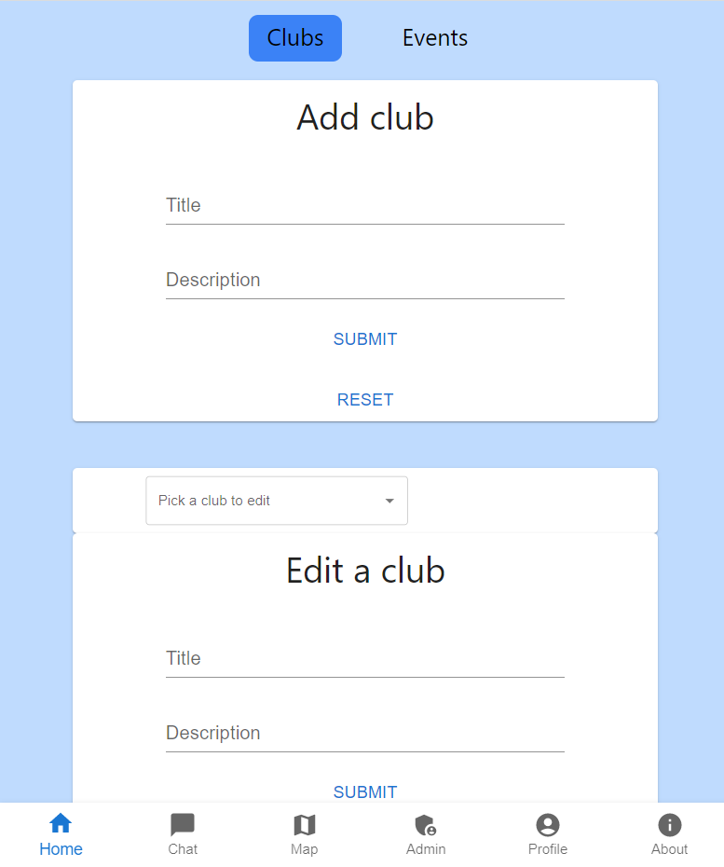

Admin view – Events

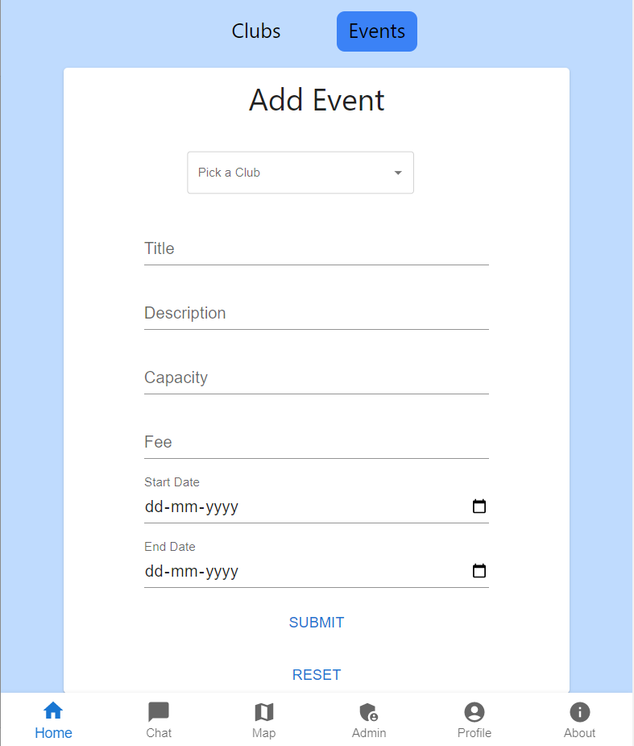

Maps

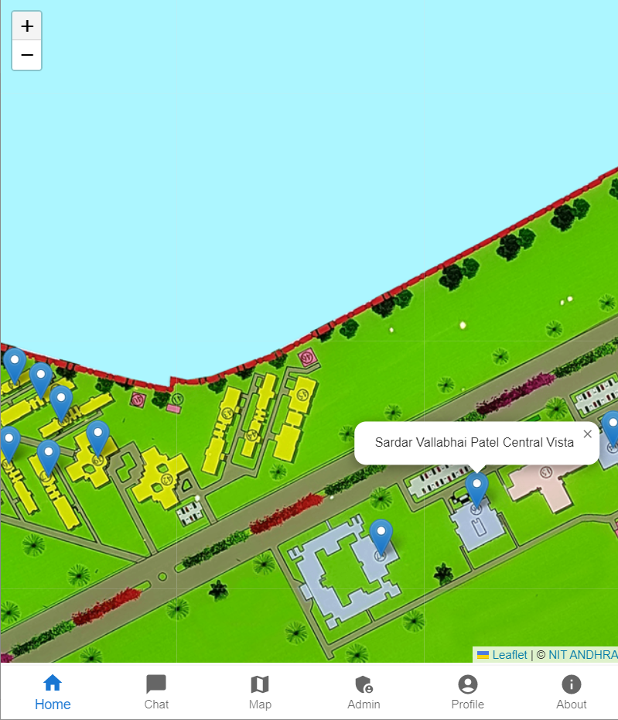

Profile

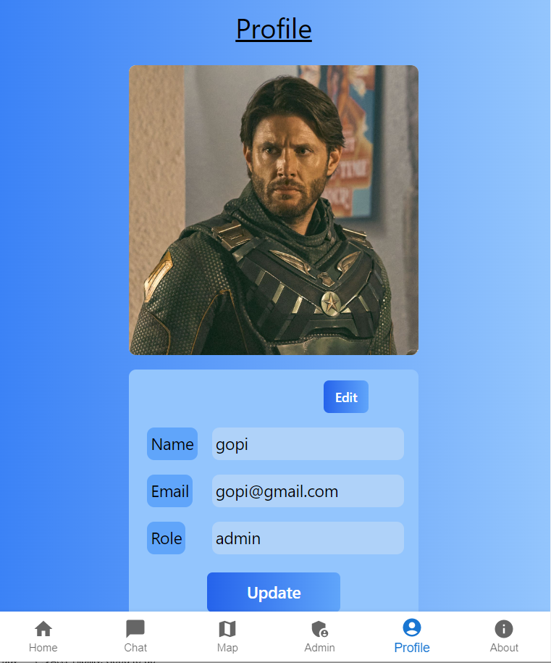

The Desktop Mode

1. **Conclusion**

**7.1 Goals achieved**

The Web app for event status and management has achieved its goals

* Easy access to event-related information
* Reduced errors in data due to automation
* User-friendly data entry screens
* Portable and flexible for future enhancements
* Web-enabled for remote access
* Fast information retrieval using search filters.

1. **References**

Node.js:

Node.js official website: https://nodejs.org/en/

Node.js documentation: https://nodejs.org/en/docs/

Node.js Tutorial: https://www.tutorialspoint.com/nodejs/index.htm

Node.js for beginners: <https://www.w3schools.com/nodejs/>

React.js:

React.js official website: https://reactjs.org/

React.js documentation: https://reactjs.org/docs/getting-started.html

React.js Tutorial: https://www.tutorialspoint.com/reactjs/index.htm

React.js for beginners: <https://www.w3schools.com/react/>

MongoDB:

MongoDB official website: https://www.mongodb.com/

MongoDB documentation: https://docs.mongodb.com/

MongoDB Tutorial: https://www.tutorialspoint.com/mongodb/index.htm

MongoDB for beginners: https://www.w3schools.com/nodejs/nodejs_mongodb.asp